I Did Something Bad
I never trust a narcissist
But they love me
So I play 'em like a violin
And I make it look oh so easy
'Cause for every lie I tell them
They tell me three
This is how the world works
Now all he thinks about is me
I can feel the flames on my skin
Crimson red paint on my lips
If a man talks shit, then I owe him nothing
I don't regret it one bit, 'cause he had it coming
They say I did something bad
Then why's it feel so good?
They say I did something bad
But why's it feel so good?
Most fun I ever had
And I'd do it over and over and over again if I could
It just felt so good, good
I never trust a playboy
But they love me
So I fly him all around the world
And I let them think they saved me
They never see it comin'
What I do next
This is how the world works
You gotta leave before you get left
I can feel the flames on my skin
He says, "Don't throw away a good thing"
But if he drops my name, then I owe him nothin'
And if he spends my change, then he had it comin'
They say I did something bad
Then why's it feel so good?
They say I did something bad
But why's it feel so good?
Most fun I ever had
And I'd do it over and over and over again if I could
It just felt so good, good
It just felt so good
They're burning all the witches, even if you aren't one
They got their pitchforks and proof
Their receipts and reasons
They're burning all the witches, even if you aren't one
So light me up (light me up), light me up (light me up)
Light me up, go ahead and light me up (light me up)
Light me up (light me up), light me up (light me up)
Light me up (light me up), light me up (light me up)
They say I did something bad
Then why's it feel so good?
They say I did something bad
But why's it feel so good?
Most fun I ever had
And I'd do it over and over and over again if I could
It just felt so good, good
Oh, you say I did something bad
Then why's it feel so good, good?
So bad, why's it feel so good?
Why's it feel, why's it feel so good? (Bad)
It just felt so good, good

Look What You Made Me Do

I don't like your little games
Don't like your tilted stage
The role you made me play
Of the fool, no, I don't like you
I don't like your perfect crime
How you laugh when you lie
You said the gun was mine
Isn't cool, no, I don't like you (oh!)
But I got smarter, I got harder in the nick of time
Honey, I rose up from the dead, I do it all the time
I've got a list of names and yours is in red, underlined
I check it once, then I check it twice, oh!
Ooh, look what you made me do
Look what you made me do
Look what you just made me do
Look what you just made me
Ooh, look what you made me do
Look what you made me do
Look what you just made me do
Look what you just made me do
I don't like your kingdom keys
They once belonged to me
You ask me for a place to sleep
Locked me out and threw a feast (what!?)
The world moves on, another day, another drama, drama
But not for me, not for me, all I think about is karma
And then the world moves on, but one thing's for sure (sure)
Maybe I got mine, but you'll all get yours
But I got smarter, I got harder in the nick of time (nick of time)
Honey, I rose up from the dead, I do it all the time (I do it all the time)
I've got a list of names and yours is in red, underlined
I check it once, then I check it twice, oh!
I don't trust nobody and nobody trusts me
I'll be the actress starring in your bad dreams
I don't trust nobody and nobody trusts me
I'll be the actress starring in your bad dreams
I don't trust nobody and nobody trusts me
I'll be the actress starring in your bad dreams
I don't trust nobody and nobody trusts me
I'll be the actress starring in your bad dreams
(Ooh, look what you made me do)
(Look what you made me do)
(Look what you just made me do)
"I'm sorry, the old Taylor can't come to the phone right now" (Ooh, look what you made me do)
"Why?" (Look what you made me do)
"Oh, 'cause she's dead!" (oh!)
Ooh, look what you made me do

…Ready for It?
Knew he was a killer first time that I saw him
Wonder how many girls he had loved and left haunted
But if he's a ghost, then I can be a phantom
Holdin' him for ransom
Some, some boys are tryin' too hard
He don't try at all, though
Younger than my exes but he act like such a man, so
I see nothing better, I keep him forever
Like a vendetta-ta
I-I-I see how this is gon' go
Touch me and you'll never be alone
I-Island breeze and lights down low
No one has to know
In the middle of the night, in my dreams
You should see the things we do, baby
In the middle of the night, in my dreams
I know I'm gonna be with you
So I take my time
Are you ready for it?
Me, I was a robber first time that he saw me
Stealing hearts and running off and never saying sorry
But if I'm a thief, then he can join the heist
And we'll move to an island-and
And he can be my jailer, Burton to this Taylor
Every lover known in comparison is a failure
I forget their names now, I'm so very tame now
Never be the same now, now
I-I-I see how this is gon' go
Touch me and you'll never be alone
I-Island breeze and lights down low
No one has to know
(No one has to know)
In the middle of the night, in my dreams
You should see the things we do, baby
In the middle of the night in my dreams
I know I'm gonna be with you
So I take my time
Are you ready for it?
Ooh, are you ready for it?
Baby, let the games begin
Let the games begin
Let the games begin
Baby, let the games begin
Let the games begin
Let the games begin
I-I-I see how this is gon' go
Touch me and you'll never be alone
I-Island breeze and lights down low
No one has to know
In the middle of the night, in my dreams
You should see the things we do, baby
In the middle of the night, in my dreams
I know I'm gonna be with you
So I take my time
In the middle of the night

Out of the Woods
Looking at it now
It all seems so simple
We were lying on your couch
I remember
You took a Polaroid of us
Then discovered (then discovered)
The rest of the world was black and white
But we were in screaming color
And I remember thinking
Are we out of the woods yet? Are we out of the woods yet?
Are we out of the woods yet? Are we out of the woods?
Are we in the clear yet? Are we in the clear yet?
Are we in the clear yet? In the clear yet, good
Are we out of the woods yet? Are we out of the woods yet?
Are we out of the woods yet? Are we out of the woods?
Are we in the clear yet? Are we in the clear yet?
Are we in the clear yet? In the clear yet, good
Are we out of the woods
Looking at it now
Last December (last December)
We were built to fall apart
Then fall back together (back together)
Ooh your necklace hanging from my neck
The night we couldn't quite forget
When we decided (we decided) to move the furniture so we could dance
Baby, like we stood a chance
Two paper airplanes flying, flying, flying
And I remember thinking
Are we out of the woods yet? Are we out of the woods yet?
Are we out of the woods yet? Are we out of the woods?
Are we in the clear yet? Are we in the clear yet?
Are we in the clear yet? In the clear yet, good
Are we out of the woods yet? Are we out of the woods yet?
Are we out of the woods yet? Are we out of the woods?
Are we in the clear yet? Are we in the clear yet?
Are we in the clear yet? In the clear yet, good
Are we out of the woods?
Remember when you hit the brakes too soon
Twenty stitches in a hospital room
When you started crying baby, I did too
But when the sun came up I was looking at you
Remember when we couldn't take the heat
I walked out, I said, I'm setting you free
But the monsters turned out to be just trees
When the sun came up you were looking at me
You were looking at me
Oh!
You were looking at me
Are we out of the woods yet? Are we out of the woods yet?
Are we out of the woods yet? Are we out of the woods? (I remember)
Are we in the clear yet? Are we in the clear yet?
Are we in the clear yet? Are we in the clear yet? (Oh, I remember)

Bad Blood
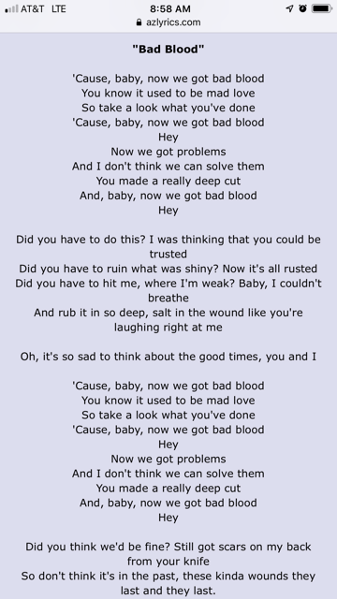

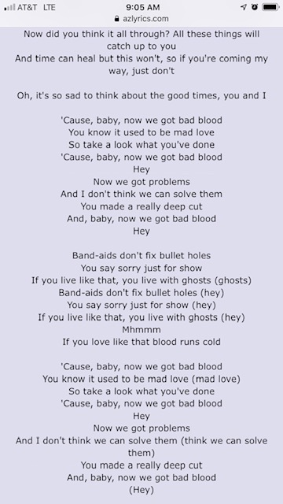
Wildest Dreams
He said, "Let's get out of this town
Drive out of the city
Away from the crowds"
I thought heaven can't help me now
Nothing lasts forever
But this is gonna take me down
He's so tall, and handsome as hell
He's so bad but he does it so well
I can see the end as it begins, my one condition is
Say you'll remember me
Standing in a nice dress, staring at the sunset babe
Red lips and rosy cheeks
Say you'll see me again even if it's just in your wildest dreams (ah ah)
Wildest dreams (ah ah)
I said no one has to know what we do
His hands are in my hair, his clothes are in my room
And his voice is a familiar sound, nothing lasts forever
But this is getting good now
He's so tall, and handsome as hell
He's so bad but he does it so well
And when we've had our very last kiss
But my last request is
Say you'll remember me
Standing in a nice dress, staring at the sunset babe
Red lips and rosy cheeks
Say you'll see me again even if it's just in your wildest dreams (ah ah) (ah ah)
Wildest dreams (ah ah)
You see me in hindsight
Tangled up with you all night
Burn it down
Some day when you leave me
I bet these memories follow you around
You see me in hindsight
Tangled up with you all night
Burnin' it down (burnin' it down)
Some day when you leave me
I bet these memories follow you around (follow you around)
Say you'll remember me
Standing in a nice dress, staring at the sunset babe
Red lips and rosy cheeks
Say you'll see me again even if it's just pretend
Say you'll remember me
Standing in a nice dress, staring at the sunset babe
Red lips and rosy cheeks
Say you'll see me again even if it's just (just pretend, just pretend) in your wildest dreams (ah ah)
In your wildest dreams (ah ah)
Even if it's just in your wildest dreams (ah ah)
In your wildest dreams (ah ah)

