Name:__________________________
Introductory Analysis of Maus
A Quick Look at the Cover
- This unit we will be reading non-fiction about the Holocaust, one of which is a biography about Art Spiegelman’s father entitled Maus (“mouse” in German). Take a look at Maus’ cover page. In addition to “Maus”, what words/phrases make up the title of the novel?

- What do you infer this means?

- On the inside cover page, Spiegelman has placed a quote by Adolf Hitler. What words would you use to describe the tone of this quote?

- Take a moment to read a few panels (boxes) on pages 5 and 6. What do you infer the relationship between Spiegelman (the boy) and his father is like? Explain.

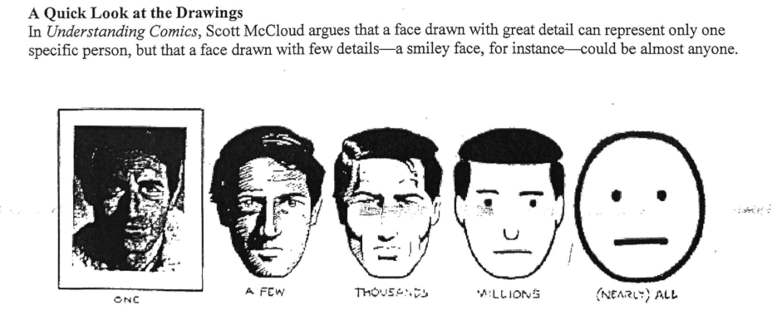
- Consulting the examples above, describe the faces in Maus. About how many people are being represented? How do you know?
- Why do you think Spiegelman drew the characters this way? (Don’t forget to consider the topic of the novel)
- Generally, artists of graphic novels draw their works twice the size of the eventual published product. When the artwork is reduced by half, the resulting image is crisp and detailed. Spiegelman drew Maus at its actual size. Look carefully at the frames (the lines around the panels) and the gutters (the space between the frames). What do you notice?
- Why might Spiegelman have drawn the frames and gutters like this? (Again, make references)
- In graphic novel, a drawing “bleeds” if it is not placed inside a box (frame) and instead touches the edge of the page. Look through the text. On what page is there a “bleed”? What is the drawing about?
- Why might Spiegelman have drawn this particular picture as a bleed? (Consider “bleed” as a pun)

